参考答案
四年级英语（下）Unit 1 My school Part A周练卷
I~IV 略
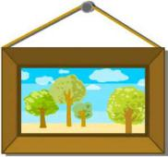
V.

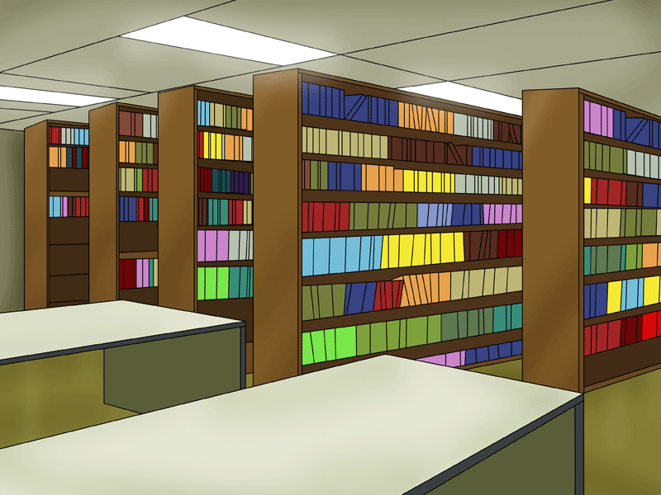

picture
teachers’ office
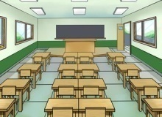
garden
library
classroom

VI. 1. C 2. A 3. B 4. C 5. A
VII. 1. school 2. library 3. teachers’ office 4. first floor; second floor
VIII. 1. B 2. B 3. A 4. C 5. B
IX. 1. b; a; c; e 2. d
X. 1. B 2. B 3. A 4. A 5. B
XI. 1. × 2. √ 3. √ 4. × 5. ×

四年级英语（下）Unit 1 My school Part B周练卷
I~IV 略
V. number, after, teacher, dinner, father
VI. 1. C 2. C 3. A 4. B 5. C
6. B 7. C 8. A 9. A 10. B
VII. This is; second floor; That is; next to; computer room
VIII. 1. B 2. A 3. C 4. E 5. D （书写略）
IX. 1. C 2. A 3. E 4. D 5. B
X. 1. A 2. C 3. B 4. B 5. C

四年级英语（下）Unit 2 What time is it? Part A周练卷
I~IV 略
V. 1. A 2. C 3. C 4. B 5. C
VI. 1. classroom 2. English class 3. playground 4. lunch 5. music room
VII. 1. B 2. B 3. C 4. A 5. A
6. C 7. A 8. B 9. B 10. A
VIII. 1. C 2. B 3. E 4. D 5. A
IX. 1. —What time is it?
—It’s 6 o’clock. It’s time for dinner.
2. —What time is it?
—It’s 10 o’clock. It’s time for PE class.
X. 1. B 2. A 3. C 4. C 5. B

四年级英语（下）Unit 2 What time is it? Part B周练卷
I~IV 略
V. 1. under, computer, mother, ruler, water, hamburger
2. birth, bird, hurt, girl
VI. 1. C 2. B 3. B 4. C 5. C
VII. 1. A 2. C 3. B 4. B 5. C
6. B 7. B 8. A 9. B 10. A
VIII. 1. C 2. D 3. B 4. A
IX. 1. It’s 6:25. It’s time to get up.
2. It’s 4:00. It’s time to go home.
3. It’s 9:00. It’s time to go to bed.
X. 1. A 2. B 3. B 4. A 5. B

四年级英语（下）Unit 3 Weather Part A周练卷
I~IV 略
V. 1. cold 2. hot 3. cool 4. warm; T-shirt
VI. 1. B 2. C 3. B 4. B 5. B
6. A 7. C 8. B 9. B 10. A
VII. 1. B 2. A 3. D 4. E 5. C
VIII. 5—2—4—3—1
IX. 1. × 2. √ 3. × 4. × 5. √

四年级英语（下）Unit 3 Weather Part B周练卷
I~IV 略
V. 1. ball, wall, small, tall, all
2. card, farmer, far, cartoon, star
VI. 1. A 2. A 3. B 4. B 5. A
VII. 1. windy 2. snowy 3. sunny 4. rainy 5. cloudy（书写略）
VIII. 1. B 2. A 3. B 4. C 5. A
6. A 7. B 8. A 9. B 10. C
IX. 1. It’s snowy in Harbin.
2. Yes, you can.
3. No, it isn’t.
4. It’s cool and windy today./It’s windy today./It’s cool today.
5. No, you can’t.（书写略）
X. 1. × 2. × 3. √ 4. × 5. √

四年级英语（下）Unit 4 At the farm Part A周练卷
I~IV 略
V. 1. of 2. at 3. so 4. about 5. at/on
6. What 7. Are 8. How 9. sheep 10. many
VI. 1. A 2. C 3. B 4. B 5. C
6. C 7. B 8. A 9. B 10. B
VII. 1. A 2. B 3. A 4. A 5. B
VIII. 1. 红色的胡萝卜 2. 黄色的西红柿
3. 棕色的土豆 4. 长豆角 5. 很多蔬菜
IX. 1. C 2. B 3. D 4. A 5. E
X. 1. √ 2. × 3. × 4. √ 5. ×

四年级英语（下）Unit 4 At the farm Part B周练卷
I~IV 略
V. 1. work, word, world, homework, worker
2. fork, pork, horse, born, for
VI. 1. sheep; rabbit; duck; horse; hen
2. potato; onion; green beans; carrot; tomato
VII. 1. carrot 2. goat 3. tomatoes 4. hens 5. potatoes
VIII. 1. short 2. hens 3. small 4. sheep 5. tomatoes
IX. 2—5—1—3—4
X. 1. D 2. C 3. A 4. B 5. E（书写略）
XI. 1. A 2. B 3. A 4. C 5. B
6. C 7. C 8. A 9. B 10. C
XII. 1. √ 2. × 3. √ 4. √ 5. √

四年级英语（下）Unit 5 My clothes Part A周练卷
I~IV 略
V. 1. C 2. C 3. A 4. B 5. B
VI. 1. B 2. C 3. B 4. B 5. C
6. A 7. B 8. C 9. A 10. C
VII. 1. Where 2. What colour 3. Who 4. What time 5. What
VIII. 1. A 2. B 3. A 4. B 5. B
IX. 1. C 2. B 3. C 4. B 5. B
6. He is from China.
7. She is in the study.
8. He is in the park.
9. She is in the office.
10. He wants to drink some water.

四年级英语（下）Unit 5 My clothes Part B周练卷
I~IV 略
V. 1. A 2. C 3. B 4. C 5. A
VI. 1. coat 2. shorts 3. jacket 4. shirt 5. sweater
VII. 1. B 2. A 3. A 4. B 5. A
6. C 7. B 8. A 9. B 10. C
VIII. 1. D 2. E 3. A 4. C 5. B（书写略）
IX. 1. e 2. d 3. b 4. c; a
X. 1. √ 2. × 3. √ 4. × 5. √

四年级英语（下）Unit 6 Shopping Part A周练卷
I~IV 略
V. 1. A 2. A 3. C 4. C 5. A

VI.
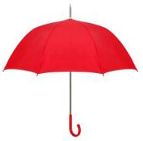
scarf 伞
umbrella 围巾

gloves 衬衫

socks 手套

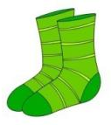
shirt 袜子

VII. 1. E 2. D 3. C 4. B 5. A
VIII. 1. B 2. A 3. B 4. A 5. B
6. C 7. B 8. C 9. A 10. C
11. C 12. A 13. C 14. A 15. B
IX. 1. √ 2. √ 3. √ 4. × 5. ×

四年级英语（下）Unit 6 Shopping Part B周练卷
I~IV 略
V. 1. B 2. A 3. B 4. C 5. C
VI. 1. B 2. A 3. B 4. C 5. C
6. A 7. A 8. C 9. B 10. B
VII. 1. B 2. A 3. E 4. D 5. C
VIII. 1. help 2. nice 3. much 4. yuan 5. take
IX. 1. C 2. B 3. A 4. C 5. B
6. B 7. A 8. B 9. B 10. C
X. 1. √ 2. √ 3. × 4. × 5. √

四年级英语（下）Unit 1 My school形成性练习
I~IV 略
V. 1. √ 2. × 3. × 4. √ 5. √
VI. 1. computer room 2. music room 3. library 4. playground
5. teachers’ office 6. art room（书写略）
VII. 1. tiger 2. water 3. computer 4. dinner 5. ruler（书写略）
VIII. 1. B 2. B 3. A 4. A 5. B
IX. （一）1. √ 2. √ 3. × 4. × 5. √
（二）又大又干净
X. 略

四年级英语（下）Unit 2 What time is it? 形成性练习
I~IV 略
V. 1. × 2. √ 3. × 4. √ 5. ×
VI. 1. eight o’clock 2. breakfast 3. music class 4. get up
5. go home（书写略）
VII. 1. bird 2. nurse 3. hamburger 4. girl 5. birthday（书写略）
VIII. 1. B 2. A 3. A 4. C 5. B
IX. 1. one 2. —What time is it? —It’s twelve o’clock.
3. —What time is it? —It’s four o’clock.
4. —What time is it? —It’s nine o’clock.
5. ten; time for music class（书写略）
X. 1. (1) 6:30 a.m. (2) have breakfast (3) have dinner (4) 9:00
2. 结束 3. B

四年级英语（下）Unit 3 Weather形成性练习
I~IV 略
V. 1. √ 2. √ 3. √ 4. × 5. ×
VI. 1. sunny 2. cloudy 3. windy 4. rainy 5. snowy（书写略）
VII. 1. ball 2. wall 3. car 4. farm 5. tall
VIII. 1. B 2. C 3. C 4. B 5. C
IX.
1. —What’s the weather like in Sydney?
—Is it cold?
—No, it isn’t. It’s hot.
2. —What’s the weather like in Moscow?
—Is it snowy?
—Yes, it is.
- —What’s the weather like today?
—Is it warm?
—No, it isn’t. It’s hot. （书写略）
X. 一、1. × 2. √ 3. × 4. × 5. ×
二、在春天，天气并不冷，但是多雨。

四年级英语（下）Unit 4 At the farm形成性练习
I~IV 略
V. 1. × 2. × 3. √ 4. × 5. √
VI. 1. cows 2. horses 3. tomatoes 4. hens 5. sheep（书写略）
VII. 1. horse 2. fork 3. homework 4. world 5. forty（书写略）
VIII. 1. B 2. C 3. A 4. C 5. A
IX. 1. —Is this a banana? —Yes, it is.
2. —Are these pigs? —No, they aren’t.
3. —Are these green beans? —No, they aren’t.
4. —Is this a ruler? —Yes, it is.
5. —Are these ducks? —No, they aren’t.（书写略）
X. 一、1. √ 2. × 3. × 4. √ 5. √
二、They are black and white.
四年级英语（下）Unit 5 My clothes形成性练习
I~IV 略
V. 1. √ 2. × 3. × 4. √ 5. ×
VI. 1. pants 2. dress 3. skirt 4. shorts 5. hat（书写略）
VII. 1. C 2. B 3. A 4. B 5. B
VIII. 1. It’s white.
2. No, it isn’t. It’s Amy’s.
3. They are pants.
4. It’s my father’s.
5. No, they aren’t. They are jackets.（书写略）
IX. 1. apple 2. table 3. toy 4. people 5. uncle （书写略）
X. 1. A 2. B 3. C 4. A 5. C

四年级英语（下）Unit 6 Shopping形成性练习
I~IV 略
V. 1. √ 2. × 3. √ 4. √ 5. ×
VI. 1. horse; sheep 2. library; playground
3. carrot; tomato; potato 4. coat; skirt; glove（书写略）
VII. 1. park 2. worker 3. small 4. shorts 5. shirt（书写略）
VIII. 1. B 2. A 3. C 4. C 5. B
IX.
1. —How much are the tomatoes? —They are $ 5.
2. —How much is the hat? —It is ¥ 20.（书写略）
X. 1. rainy; windy 2. new pants 3. under the
4. Yes; she does 5. breakfast（书写略）

四年级英语（下）阶段性达标练习题（期中）
听力材料
I. 1. The boy likes that bird in the tree.
2. My computer is on the desk.
3. Let’s read books quietly in the library.
4. Can I go to the park now?
5. What’s the weather like today?
II. 1. It’s seven thirty in the evening.
2. My sister would like a hamburger.
3. Be careful! The soup is very hot.
4. It’s time for me to go home.
5. Can I play in the garden today?
III. 1. I’m in New York. It’s seven ten in the morning now.
2. It’s time for art class. Let’s go to the art room!
3. Here’s the world weather. Today it’s sunny and warm in Singapore.
4. It’s cloudy. It’s seven degrees to twenty degrees today.
5. It’s ten o’clock. It’s time to go to bed.
IV. 1. Show me your arm.
2. This girl is my friend.
3. The ball is under the chair.
4. Can I have some rice and fish for dinner?
5. Our classroom is on the first floor.
参考答案
听力部分
- 1-5 ABCBA
- 1-5 BBAAB
- 1-5 BABAC
- 1. arm 2. girl 3. ball 4. dinner 5. first
笔试部分
- 1-5 TTFFF
- 1. maths; Chinese
- playground; gym
- sunny; warm
- go home; have breakfast
- London; Sydney
VII. 1-5 CABCA
VIII. 1-5 CEBDA
IX. 一、3-2-5-1-4
二、地板
三、略
四年级英语（下）阶段性达标练习题（期末）
听力材料
- 1. These apples are cheap. I’ll buy them.
2. I’d like some milk and bread for breakfast.
3. It’s warm, so I put on my shirt.
4. The second picture on the wall is Mike’s.
5. It’s time for music class. Let’s sing and dance.
II. 1. It’s seven thirty in the morning. It’s time to get up.
2. There is a sheep and a goat on the farm.
3. The juice is cool, but the tea is hot.
4. I want to wear my dress and hat for the party.
5. This nice scarf is Amy’s.
III. 1. This is the library. Please keep quiet.
2. It’s cold today. I will wear my sweater.
3. B: It’s six thirty. It’s time to do my homework.
4. Look at these red tomatoes. They are two point five yuan.
5. It will rain. You’d better take an umbrella.
IV. 1. Let’s have some bread and water for dinner.
2. The girl’s mother is a nurse.
3. My short brother wears his shorts today.
4. That tall boy likes to play ball.
5. A green apple is on the table.
参考答案
听力部分
- 1-5 ABCBA
- 3-1-5-2-4
- 1-5 BACAB
- 1. dinner 2. nurse 3. shorts 4. ball 5. apple
笔试部分
- 1. river 2. skirt 3. park 4. story 5. table
- 1-5 BCEDA
- 1-5 BCACC
- 1. This is the gym.
- It’s time to get up.
- It’s windy in Beijing.
- The dress is pretty.
- This is Amy’s hat.
- 一、1-5 ××××√
- 干净的
- 略

